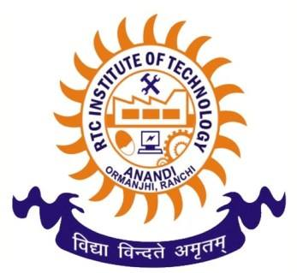
RTC INSTITUTE OF TECHNOLOGY
Anandi, Ormanjhi, Ranchi-835219
Passport size Photo

To,
The Transport In-charge,
RTCIT, Ranchi,
Sub:- Application for availing bus facility
Dear Sir,
I ________________________ student of ________ semester, B.Tech / Diploma engineering [Please √] _______________________Branch. I want to avail the bus facility from _________________month, ___________year and I will deposit bus fee of three months as per the transport rules.
Please allow me to avail the bus facility and issue my Bus pass, for that I shall be thankful to you.
Thank You
Yours faithfully
________________________________

Details:-
Stoppage Place:-________________________________
Father’s name:-
Contact No:-
Class Roll No:-
Branch:-
Date of Application:-
Address:-

Note :- For any query contact transport In-charge

